**M1: compare the limitations of different hardware and software packages used in graphics work**

**Hardware**

|  |  |  |  |
| --- | --- | --- | --- |
| **Type of Storage** | **Features** | **Limitations** | **Image** |
| **Memory and Graphic Cards (USB, Graphic Cards and CD ROM)** | Universal Serial Bus (USB) was designed in 1996 to store data, which can be ejected as a hardware product. It has a range of capacities that range from 4GB to 62GB. Obviously, the higher the capacity, the more you can store on the USB.  Graphic card is stored inside the system unit with the motherboard. It is connected within the motherboard and the main features that it holds is that it helps the user visualise better graphics, especially for gamers.  CD ROM is a type of file storage where you can store data such as files, documents, images, music, videos etc. The size of it varies. It is important as it identifies how much data you can store on the specific storage. Data stored on CD ROM varies from 650MB to 900MB. It depends on the thickness if the thickness is greater, the megabyte increases. These can be used as a backup. Therefore, if any files are lost, you can restore them by using this CD. | The limitations for memory cards is that they are small and they have important information stored inside them. If they are lost or deleted. If it is lost, an unauthorised user can access the memory card and they can use the information without the original owner knowing.  The limitations on graphic cards is that it could affect the performance of the computer’s speed. In addition, the higher you set your resolution, the smaller the icon and text becomes. | http://upload.wikimedia.org/wikipedia/commons/thumb/8/8f/SanDisk_Memory_Card_with_Adapter.jpg/300px-SanDisk_Memory_Card_with_Adapter.jpgATI Radeon HD 4770 Graphics Card-oblique view.jpg |
| **Internal Memory (RAM)** | **RAM** is also known as random access memory is used to store data. This is inserted on the motherboard that it is located there. When the computer is switched on, the files that are stored on the RAM automatically be operating as long as the computer is running. All the documents that you create is stored on the RAM. | The limitations on RAM is that when the power turns off, the information is gone. It does not process or save any information is set. This means when a user turns off the computer without saving anything, the user automatically loses the unsaved work. | http://upload.wikimedia.org/wikipedia/commons/thumb/c/ca/Memory_module_DDRAM_20-03-2006.jpg/220px-Memory_module_DDRAM_20-03-2006.jpg |
| **Scanner** | **Scanner** is sort of fittings used to output hard duplicates, for example, pictures or content, after it is then moved into the workstation through USB link or in some cases even remotely. After the picture being moved into the machine it can then be altered, for example, uprooting a few points of interest or including a few subtle elements, and afterward be printed if the client needs it in a hard duplicate. At the point when the hard duplicate is, no doubt examined the client can pick how the picture ought to be seen either dark & white, colour, negative, and so forth. | The limitations on scanner is that it gets dirty quickly. The owner needs to clean the scanner each time. In addition, the scanner does not give a clear image whilst the scanner is moving.  It can take up a lot of space. | http://www.vintagecomputing.com/wp-content/images/sitewide/rsotw_scanner_small.jpg |
| Digital Camera device | Digital camera drivers is a device that enables communication along with a computer and this device. Modern digital camera drivers use USB cables to connect the two together. Once you connect the two together, you can transfer, print, and edit the photo on the computer using specific programmes. As the image demonstrates, you insert both cards into the USB port in the computer. | The limitations on digital camera is that any result in corrupt memory card, it could result in losing all the photos. Therefore, any Photoshop edits has to wait. | http://i01.i.aliimg.com/wsphoto/v1/288322605/Free-shipping-24-In-1-USB-2-0-Digital-Camera-Memory-Card-Reader-9779.jpg_350x350.jpg |
| Hard drive | Hardware Disk Drive (HDD) is installed within the system unit on the computer motherboard. As any other file storage, it stores files on it. It can store gigabyte, megabyte and terabyte. As the image shows below, each of the following increase by storage. Therefore, if you have 1TB, you can store as many files as you want until it finishes. | The limitations on the size is large. Therefore, more power will result in being used. It requires a lot of power for it to work. In addition, any photo edits that are saved, it is hard to recover if lost. | http://www.fstopacademy.com/wp-content/uploads/2012/07/hard-drive-.jpeg |
| Printer | A printing device simply prints out pictures that are requested by the user. It has to be connected to the computer for it to be done. Any program such as Adobe Photoshop can print out edited images. | The limitations on that is that the paper or the ink. If the paper or ink has ran out, it has to be replaced straight away for printing to be complete. Without each of them, printing cannot happen. | http://www.advancetec.co.uk/media/catalog/product/cache/1/image/1250x1250/b65b7106e6199ae52d7f08f5a5033ae0/e/p/epson_expression_home_xp-405_all_in_one_printer_copier_scanner_wifi_usb.jpg |

**Software**

|  |  |  |  |
| --- | --- | --- | --- |
| **Type of Software** | **Features** | **Limitations** | **Image** |
| **Adobe Photoshop** | Adobe Photoshop is a graphic software where images are used to edit images as far as possible. Photoshop has many features to allow users to think that it may not even be Photoshop; it is one of the leading graphic software. Some of the tools that may be used include is colour pick. Any image can be used and it can do the “impossible”. Some people could not tell whether Photoshop was used on some photos. | When using Photoshop for the first time, it is very difficult to navigate. You need to know where everything is and how to edit tools properly. The limitation is that you need to take time and use it every day if you want to get better at it. | http://t3.gstatic.com/images?q=tbn:ANd9GcT8p8zaWOffnJVzdSUQChzriUfIAACJSY2pbwzi95QtpxobVRpjRA |
| **Paint** | Paint is different from Photoshop as it is “childlike”. It is a software where you can create, draw and edit images on this software. It has less tools than Photoshop. | Microsoft has only a few features. This product is exceptionally restricted to characteristics and impacts while the other two products have mixed bags of characteristics that permits the client to alter and control pictures. | http://www.fayette.k12.il.us/99/paint/paintscreen.gif |

**COMPARISON OF PRINTER AND SCANNER**

They are many differences that consist between a printer and a scanner. A scanner scans the image for it to be a software manipulation. For example, if a person prints out a document and deletes it, the user can scan it and send it back as an original use for a software. It is simple to use. However, only a printer is used to print out documents. It does not do anything else. It only prints out documents, similarly with the printer. Both objects need paper for it to work, you can get all-in-one printer where you can scan, photocopy and print at the same time. Scanners need a USB device for it to send the software onto the USB for it to work.

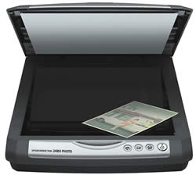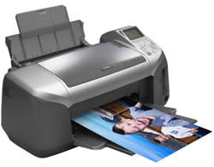

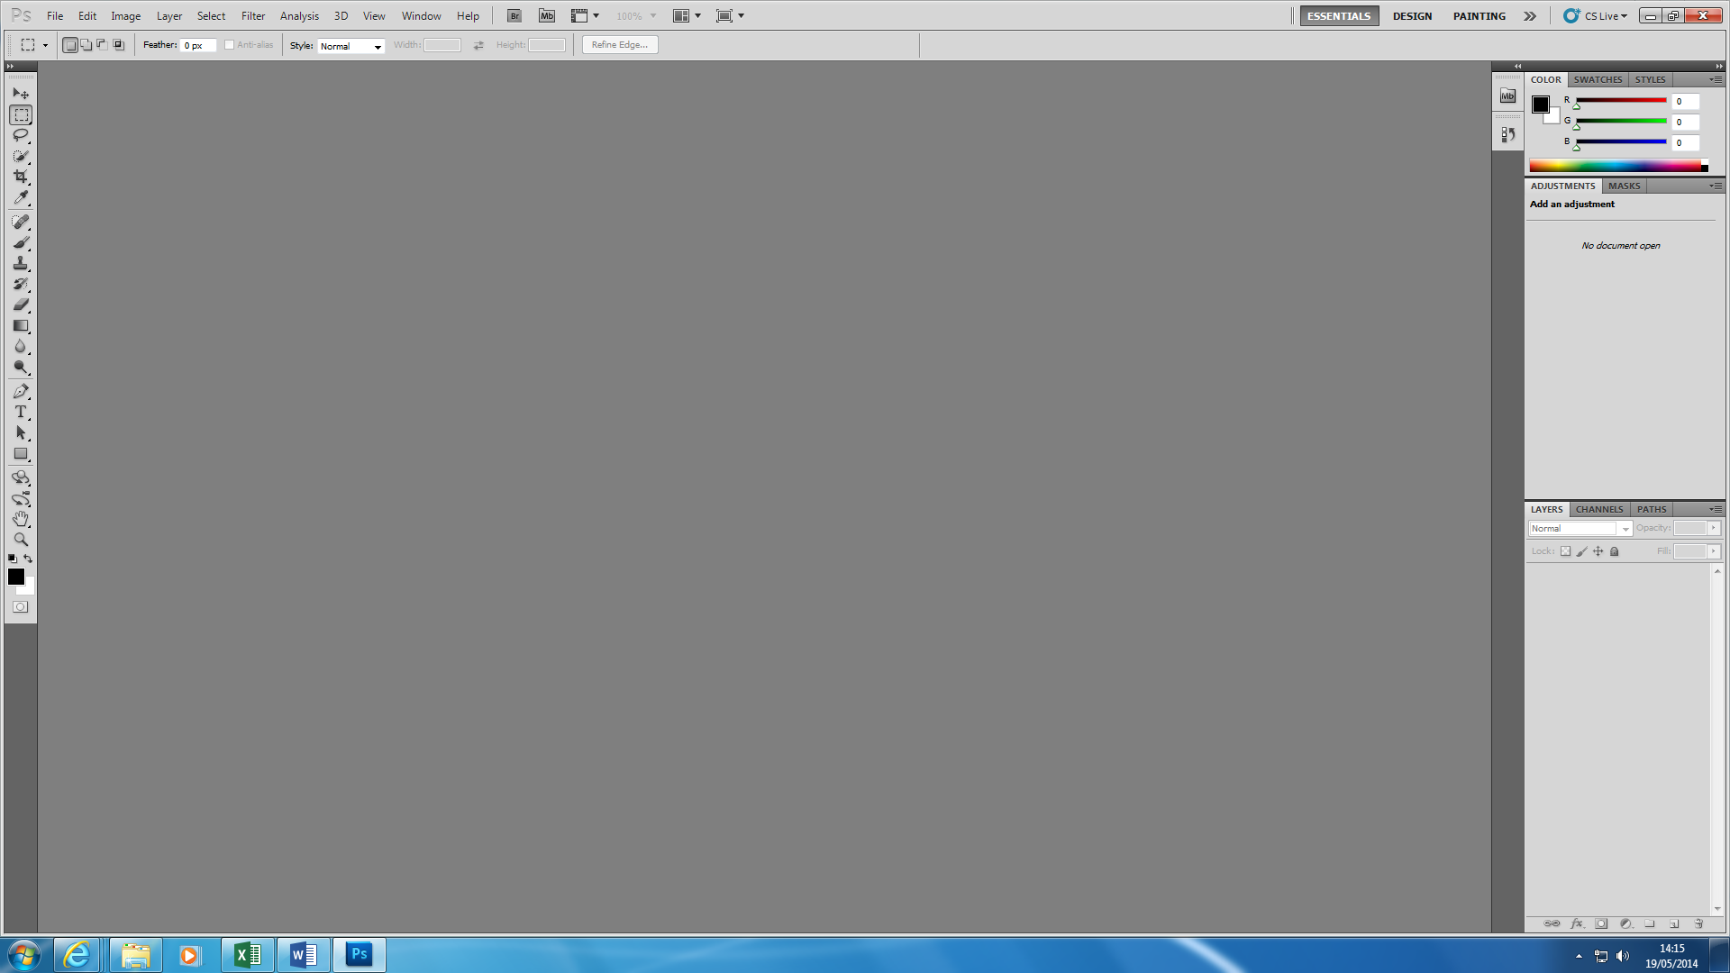**COMPARISON OF PAINT AND PHOTOSHOP**

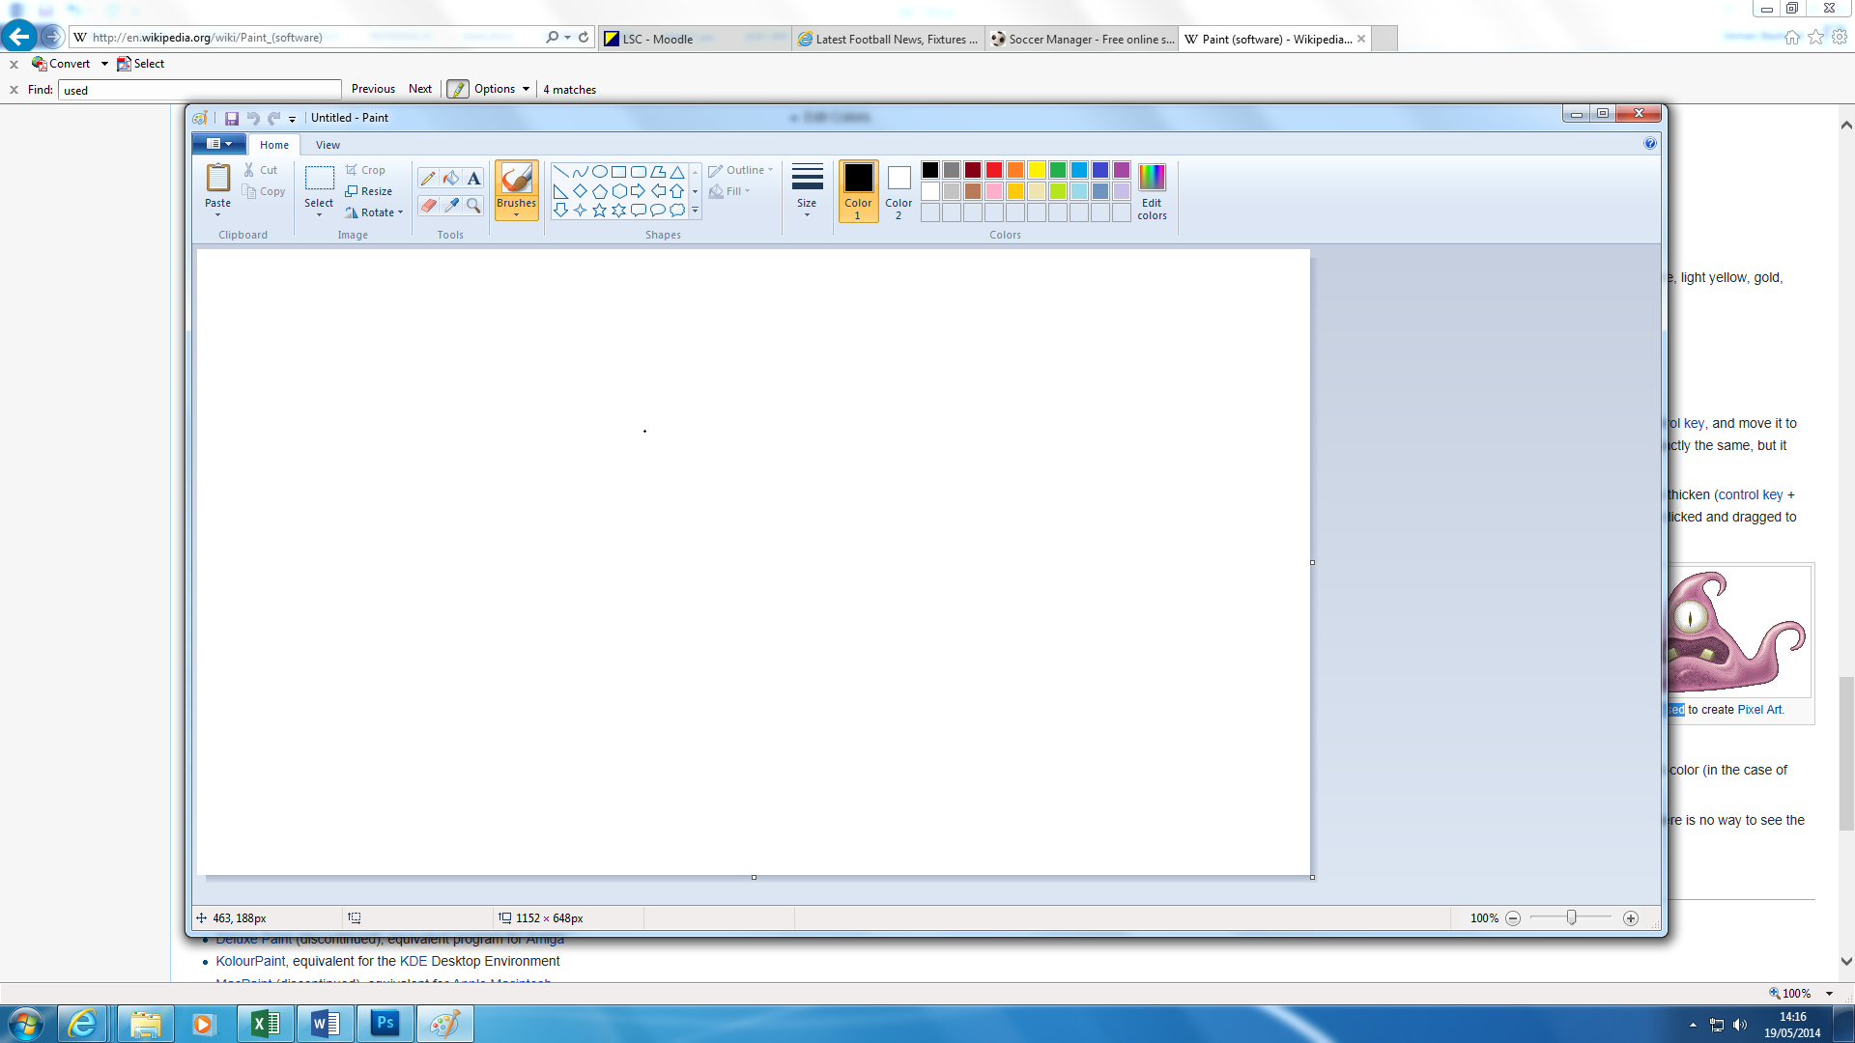I am going to compare both Paint and Photoshop. They are many big differences according to both software. MS Paint is used often to create pixel art. The tools used for Photoshop is very complex, but MS Paint is very basic. As you can see both of the tools below, MS Paint looks basic. It is very simple to use. However, Photoshop is complex. They are both used for the same thing – edit images. Photoshop has tools that MS Paint does not have such as brush tool. It does not use only this tool. It goes into more detail with the tool and use more tools whilst using brush tool. The difference is that for MS Paint, it is installed on Windows – which means it comes free. However, Adobe Photoshop, you have to pay for it and it is expensive; it is around £300 to £500. MS Paint it is very easy to use. Once you open the software up, you automatically know where everything is place. Whereas, Adobe Photoshop is very different. It is complex and you need to spend a lot of time developing skills that others cannot develop. You need to spend time on this program to be very good at it. Creating pictures on each is very different. If you create an image on MS Paint, it looks very basic and simple. However, Adobe Photoshop is different. It looks much more professional and professional ICT users use Photoshop as a daily basis.

